**4.3 Performance and Stress Testing Definition:**

Performance and stress testing is the process of determining the responsiveness and stability of the PrimeNumbers function under different workloads i.e. given different inputs that require a lot of little computation/processing power.

**Participants:**

This test will be performed by Mpinane Mohale

**Methodology:**

The test scripts for this test will be written by Mpinane Mohale.

The test script reads in an input file with the name “performance_test_inputfile.txt”.

The input file consists of rows of possible values of X (the input argument for the PrimeNumbers function). The values must be inputted in a linear ascending order. An example of the file is in the figure below

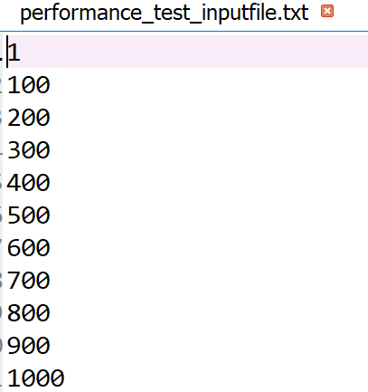

Once the file has been read in, the PrimeNumbers function is tested using each row in the file and the performance of the function foreach input is plotted on a graph.

A theoretical analysis of the PrimeNumbers algorithm was performed to assess its performance as seen below.

**Complexity of PrimeNumbers:**

In this algorithm, the most work is done in the for loop so counting how many times the loop executes would be a fair estimate of the algorithm’s performance.

For any given valid value of X (let’s say n >= 2) the while loop executes n-1 times which means the for loop condition is checked n-1 times. Now, the for loop executes in various number of times depending on the value of counter but it could execute for a minimum of 1 times and a maximum of n-1 times.

Our best case is when n=2. In this case the complexity function is g(n)=(n-1)(1)= n-1 so the algorithm is O(n)

Our worst case is when n>=3. In this case the complexity function is g(n)=(n-1)(n-1)=n^2 -2n+1 so the algorithm is O(n^2)

From our theoretical analysis of the PrimeNumber we expect the function to follow a n^2-like pattern. This means that as the input increases the time increases quadratically. The result of the test script is a graph like the one below:

<<>picture of graph>

Note:

To run the test script:

You need to have installed matplotlib.

To install matplotlib run this in the terminal:

python -mpip install -U pip

python -mpip install -U matplotlib